SET 1

Q1. (Data Structures – 5 Marks)
Using AI assistance, write a Python program to implement a Stack using a list.
Perform the following operations:
- Push 5 elements
- Pop 2 elements
- Display the remaining stack
Explain how AI helped generate or optimize your structure.
Code:
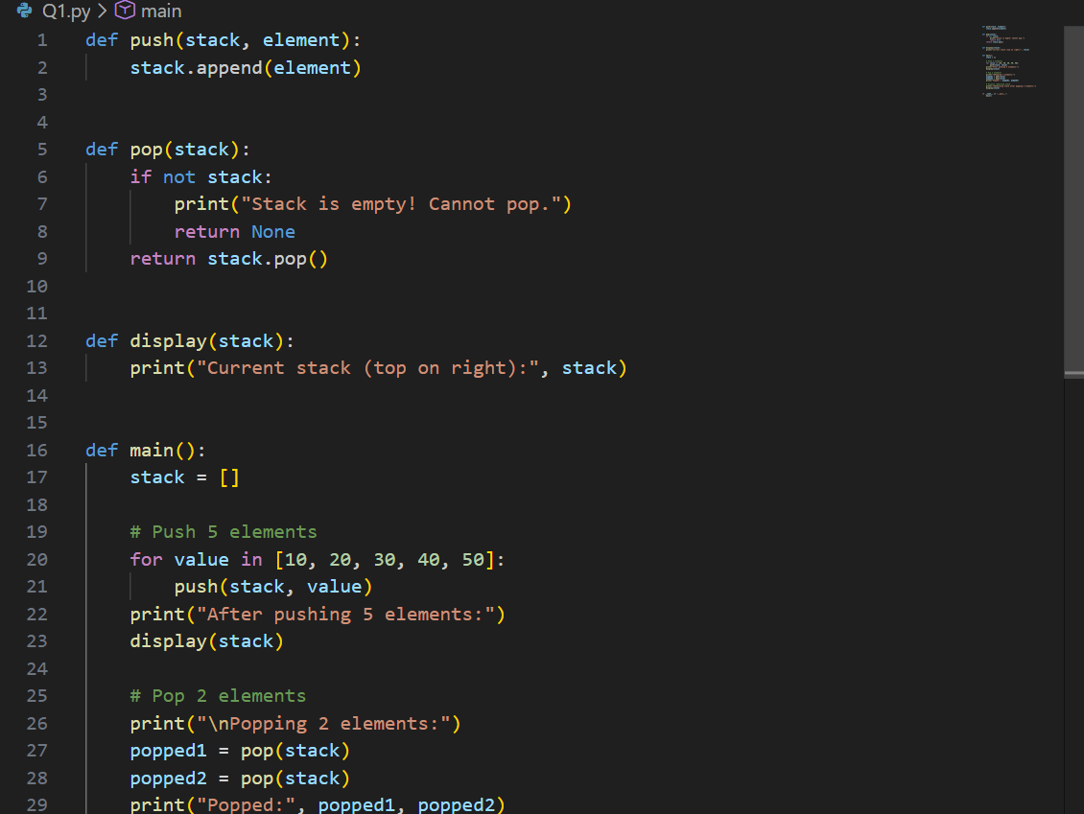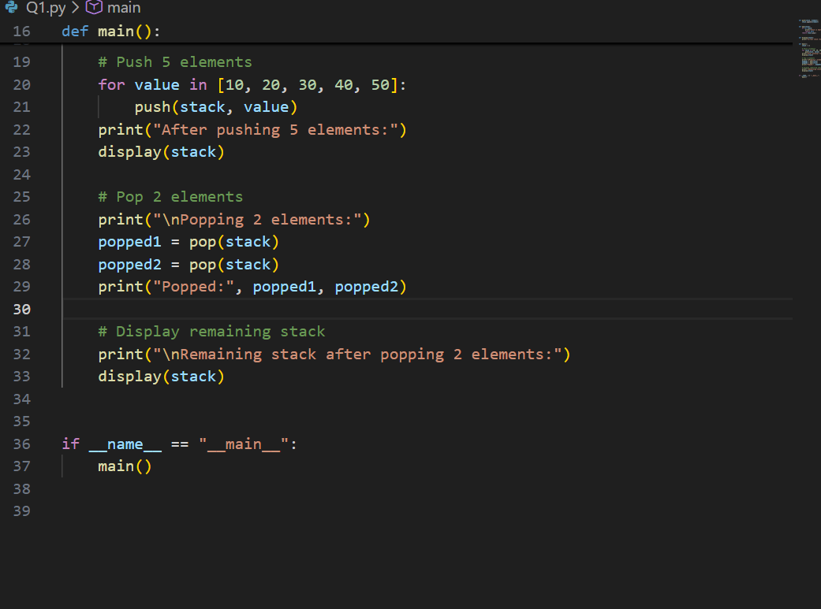

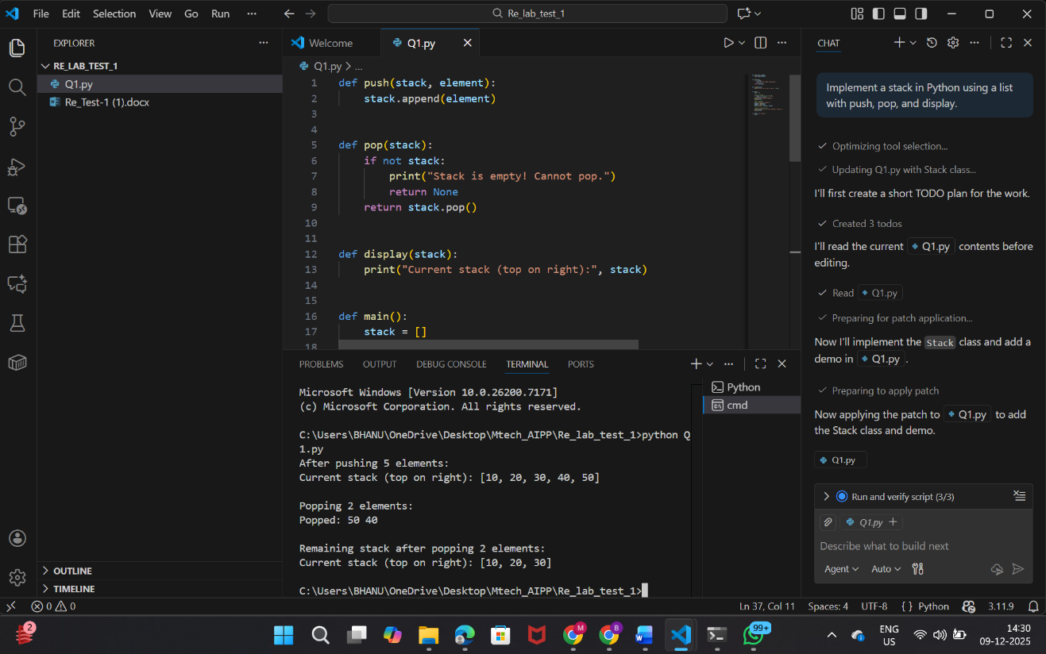

Output:
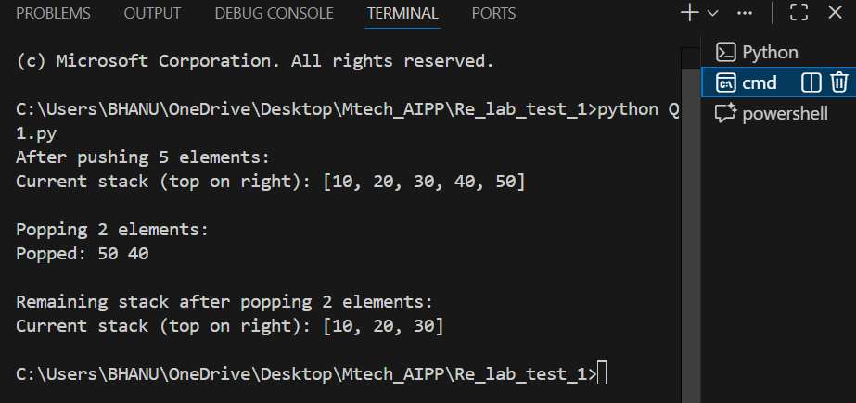
I used AI assistance to generate the basic stack structure using a Python list. AI suggested separate functions for push, pop, and display. This helped me organize the code better and reduced the time to write boilerplate logic.

Q2. (Web Frontend – 5 Marks)
With AI tools, develop an interactive To-Do List App using HTML, CSS, and JavaScript.
Include features:
- Add task
- Delete task
- Mark as completed

Code:
Index.html
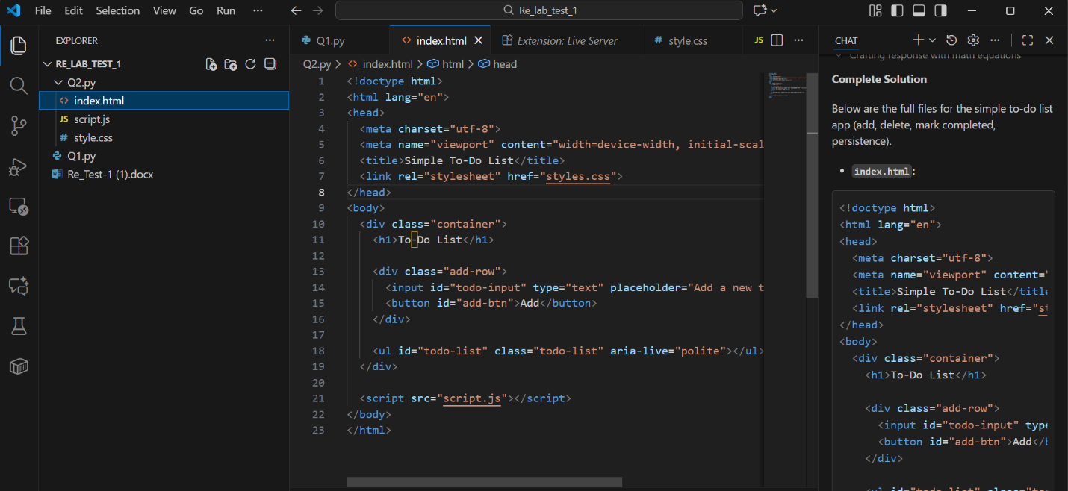

Style.css:
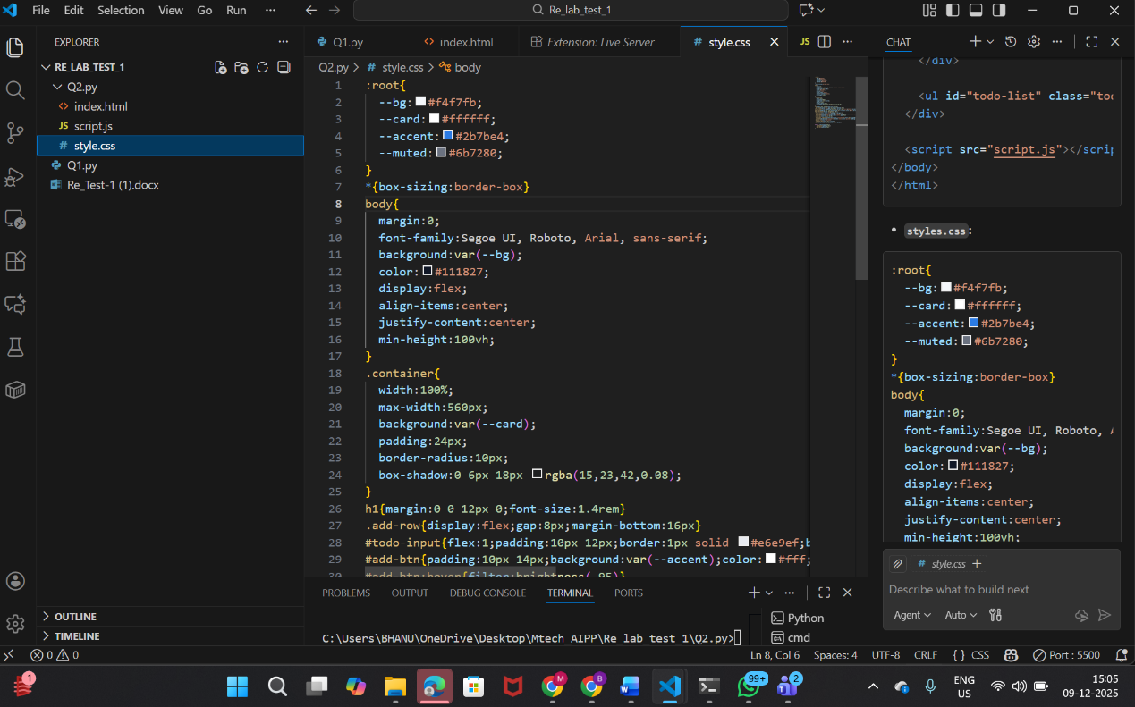

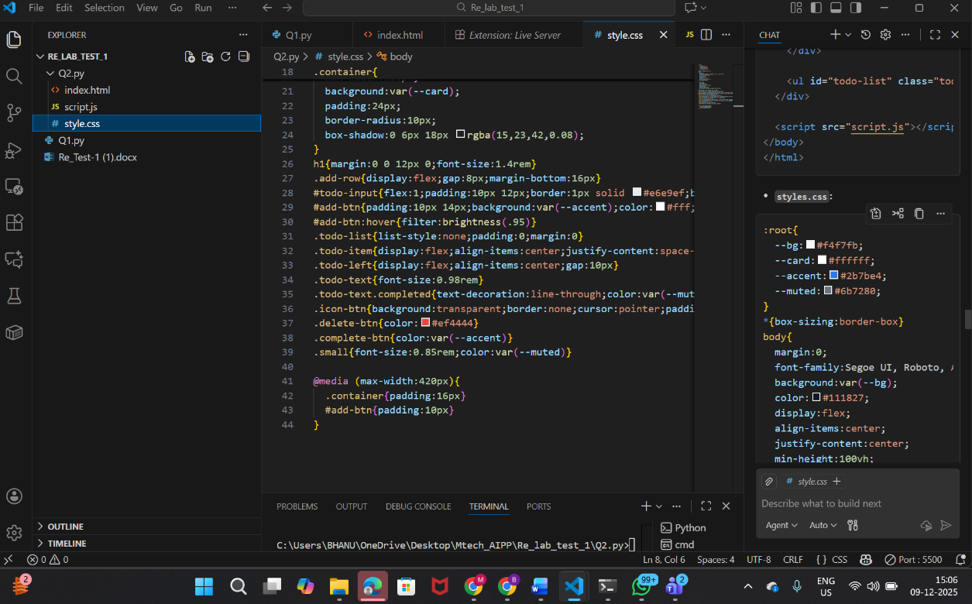

Script.js:
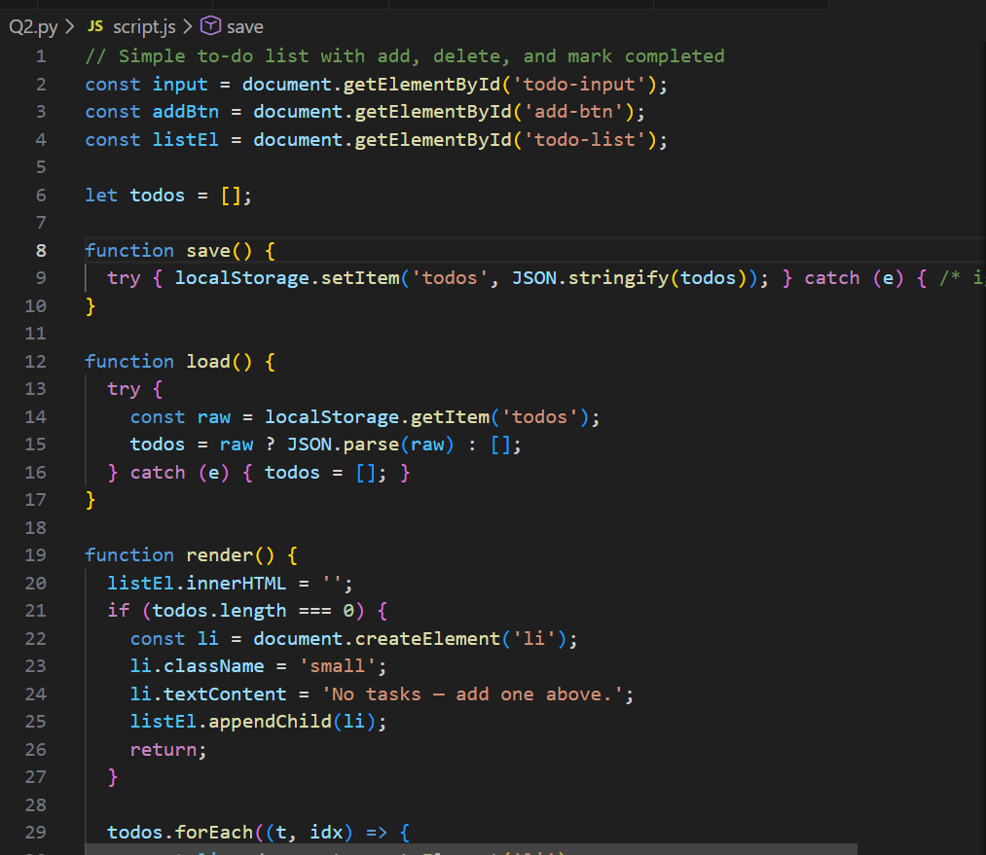

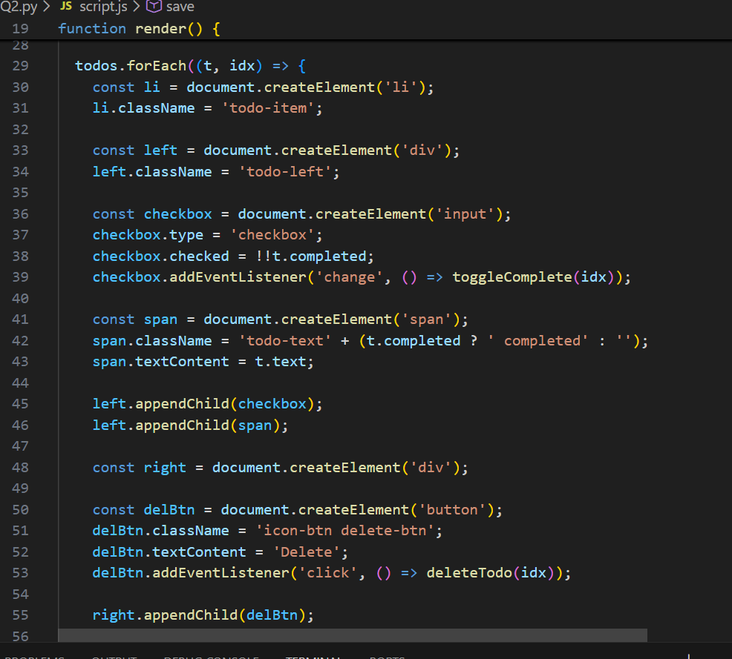

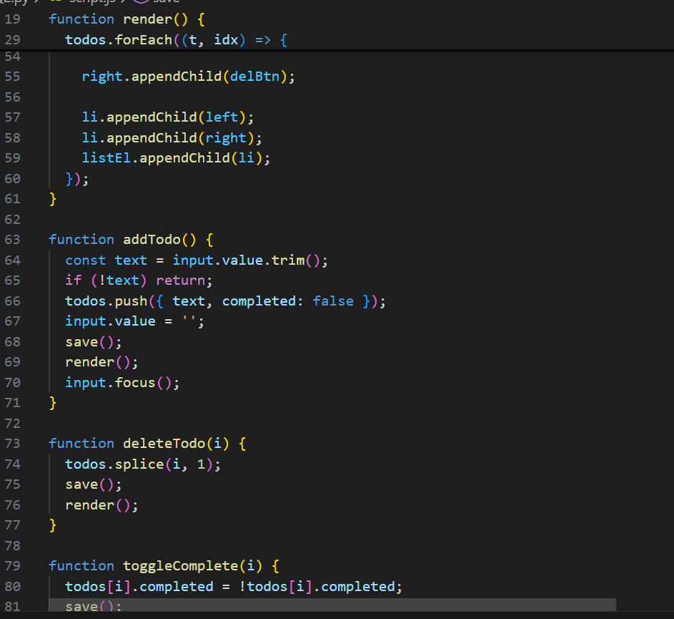

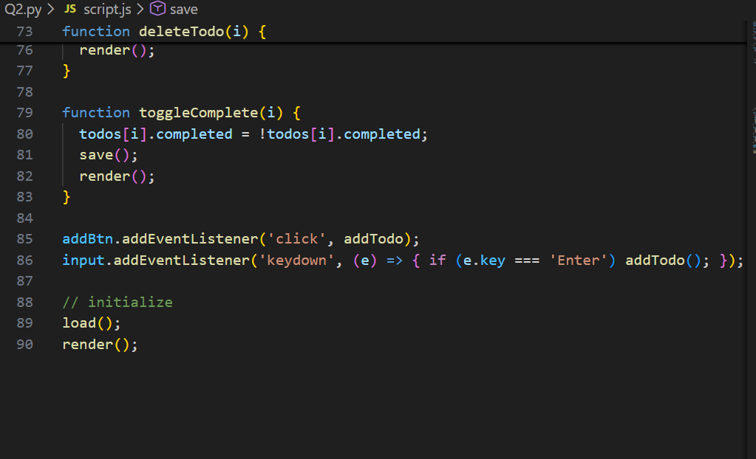

Output:




